## PRACTICAL TWELEVE: ONE WAY AND TWO WAY ANOVA WITH SPSS

1. Generate a one-way ANOVA problem and corresponding data.
2. Set the hypothesis for the problem.
3. Give a step by step procedure for running the analysis with SPSS .
4. Give the decision rule and conclusion based on the outcome of your analysis.
5. Give the decision rule and conclusion based on the outcome of your analysis.

SOLUTION

QUESTION: Run the study of the effects of tea on weight (kg) loss of patients with respect to Green Tea, Black Tea and No Tea.

* After inputting your data and noting every condition.

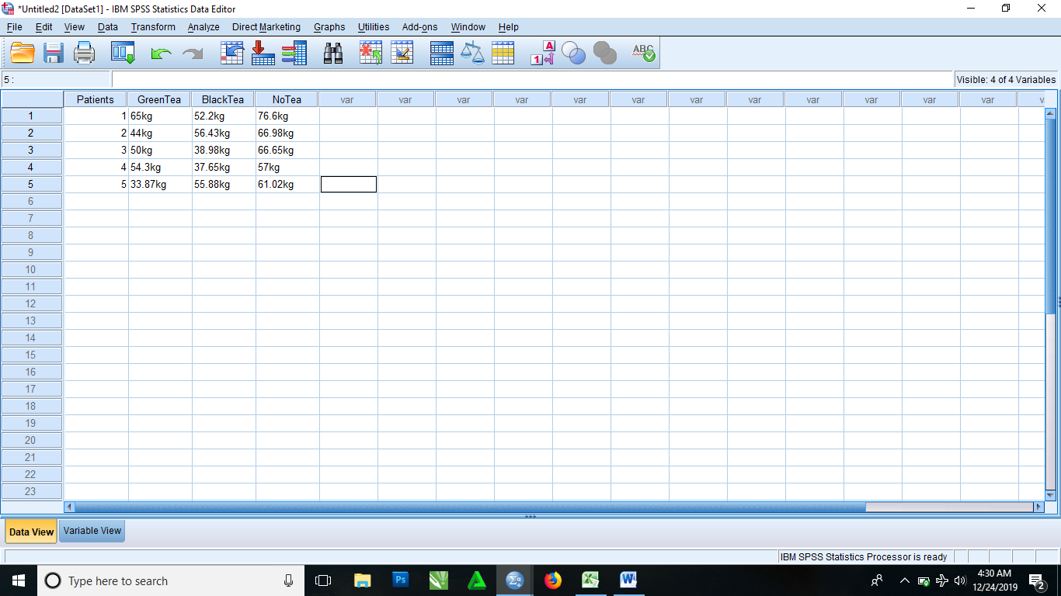

* From the menu

Select Analyze > Compare means > One way ANOVA

* It then brings you to a dialog box, where you select Patient and drag to the Factor box and also select and drag other variables to the Dependent List box
* Click OK.

|  |  |  |  |  |  |  |
| --- | --- | --- | --- | --- | --- | --- |
| **ANOVA** | | | | | | |
|  | | Sum of Squares | df | Mean Square | F | Sig. |
| GreenTea | Between Groups | 538.065 | 4 | 134.516 | . | . |
| Within Groups | .000 | 0 | . |  |  |
| Total | 538.065 | 4 |  |  |  |
| NoTea | Between Groups | 218.931 | 4 | 54.733 | . | . |
| Within Groups | .000 | 0 | . |  |  |
| Total | 218.931 | 4 |  |  |  |
| BlackTea | Between Groups | 339.022 | 4 | 84.756 | . | . |
| Within Groups | .000 | 0 | . |  |  |
| Total | 339.022 | 4 |  |  |  |

1. Generate a two samples problem and corresponding data.
2. Set the hypothesis for the problem.
3. Give a step by step procedure for running the analysis with SPSS.
4. Give the SPSS data structure for the analysis and run the analysis.
5. Give the decision rule and conclusion based on the outcome of your analysis.

SOLUTION

* After inputting your data into the SPSS

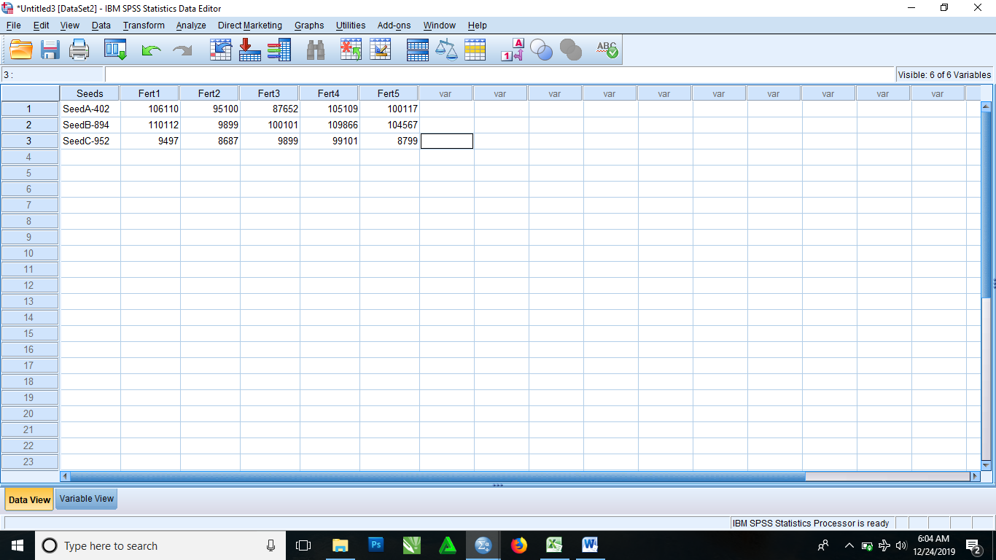

* From the menus
* Select Analyze > General Linear Model > Multivariate
* It then brings you to a dialog box where you click and drag Seed to the fixed factor(s) box and then click and drag other variables to the Dependent Variables box
* Click OK.

|  |  |  |  |  |  |  |  |
| --- | --- | --- | --- | --- | --- | --- | --- |
| **Tests of Between-Subjects Effects** | | | | | | | |
| Source | Dependent Variable | Type III Sum of Squares | df | Mean Square | F | Sig. | Partial Eta Squared |
| Corrected Model | Fert1 | 6491155332.667a | 2 | 3245577666.333 | . | . | 1.000 |
| Fert2 | 4909295304.667a | 2 | 2454647652.333 | . | . | 1.000 |
| Fert3 | 4778969138.000a | 2 | 2389484569.000 | . | . | 1.000 |
| Intercept | Fert1 | 16983022320.333 | 1 | 16983022320.333 | . | . | 1.000 |
| Fert2 | 4308168865.333 | 1 | 4308168865.333 | . | . | 1.000 |
| Fert3 | 13022104368.000 | 1 | 13022104368.000 | . | . | 1.000 |
| Seeds | Fert1 | 6491155332.667 | 2 | 3245577666.333 | . | . | 1.000 |
| Fert2 | 4909295304.667 | 2 | 2454647652.333 | . | . | 1.000 |
| Fert3 | 4778969138.000 | 2 | 2389484569.000 | . | . | 1.000 |
| Error | Fert1 | .000 | 0 | . |  |  |  |
| Fert2 | .000 | 0 | . |  |  |  |
| Fert3 | .000 | 0 | . |  |  |  |
| Total | Fert1 | 23474177653.000 | 3 |  |  |  |  |
| Fert2 | 9217464170.000 | 3 |  |  |  |  |
| Fert3 | 17801073506.000 | 3 |  |  |  |  |
| Corrected Total | Fert1 | 6491155332.667 | 2 |  |  |  |  |
| Fert2 | 4909295304.667 | 2 |  |  |  |  |
| Fert3 | 4778969138.000 | 2 |  |  |  |  |
| a. R Squared = 1.000 (Adjusted R Squared = .) | | | | | | | |